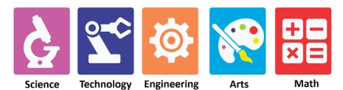


Age Criteria for Different Grades – Academic Year 2027–28

The Government of Maharashtra permits children to be admitted to Grade 1 if they have completed 5 years and 6 months of age by June.

However, based on our experience, we strongly recommend that children be born on or before 30 September, rather than the December cut-off. Our experience suggests that children who are slightly older at entry often demonstrate greater readiness, confidence and comfort across academic and co-curricular areas.
During the primary years, even a difference of a few months can make a meaningful difference in a child's academic, social, emotional and overall developmental readiness.

Sr. No. | Grade | Born on or before | Minimum Age | Recommended Age
1 | Play Group | — | 1 year 9 months at the time of admission | 1 year 9 months at the time of admission
2 | Nursery | 31 December 2024 | 2 years 6 months on 1 June 2027 | 2 years 9 months on 1 June 2027
3 | Junior KG | 31 December 2023 | 3 years 6 months on 1 June 2027 | 3 years 9 months on 1 June 2027
4 | Senior KG | 31 December 2022 | 4 years 6 months on 1 June 2027 | 4 years 9 months on 1 June 2027
5 | Grade 1 | 31 December 2021 | 5 years 6 months on 1 June 2027 | 5 years 9 months on 1 June 2027
6 | Grade 2 | 31 December 2020 | 6 years 6 months on 1 June 2027 | 6 years 9 months on 1 June 2027
7 | Grade 3 | 31 December 2019 | 7 years 6 months on 1 June 2027 | 7 years 9 months on 1 June 2027
8 | Grade 4 | 31 December 2018 | 8 years 6 months on 1 June 2027 | 8 years 9 months on 1 June 2027


Note: The minimum age criteria are based on the applicable government guidelines. The recommended age reflects the school's experience and recommendation regarding children's readiness for the academic and co-curricular demands of each grade.

